Tugas Mata Kuliah
ALGORITMA DAN PEMROGRAMAN
Dosen :

TUGAS PRAKTIKUM 4



Oleh :
Muhammad Faqih
(2020230032)

SARJANA
PROGRAM STUDI TEKNOLOGI INFORMASI 20
UNIVERSITAS DARMA PERSADA
BEKASI
2022
2. Output A1B1C1D1E1F1G1H1J1K1
-A4000
MOV AH,2
MOV CX,B
MOV DL,41
INT 21
INC DL
MOV BL,DL

MOV DL,31
INT 21

MOV DL,BL
LOOP 4007

MOV AX,4C00
INT 21

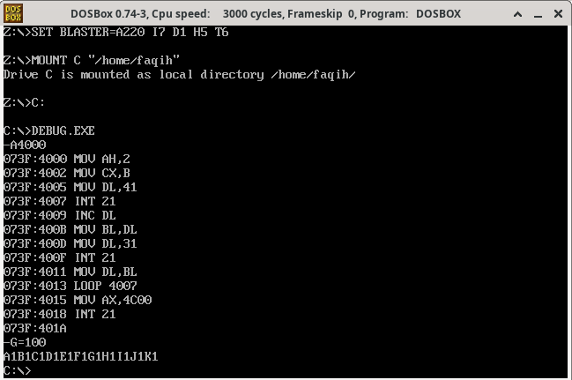
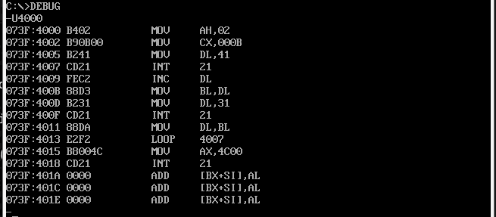
4. Output AbCdEfGhIj
-A4000
MOV AH,2
MOV CX,5
MOV DL,41
INT 21
MOV BL,DL
ADD BL,2

MOV BH,DL
ADD BH,21
MOV DL,BH
INT 21

MOV DL,BL
LOOP 4007
MOV AX,4C00
INT 21

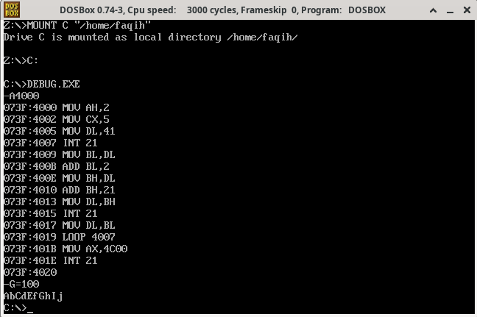
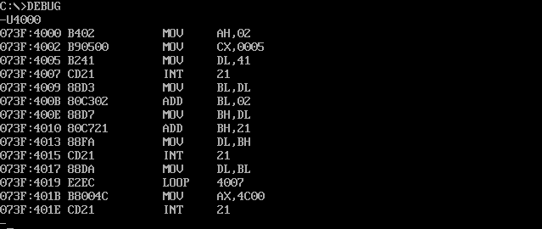

6. Output A B C D E F G H I K L M N O P Q R S T V X Y Z
-A4000
MOV AH,2
MOV CX,1A
MOV DL,41
INT 21
INC DL
MOV BL,DL

MOV DL,20
INT 21

MOV DL,BL
LOOP 4007
MOV AX,4C00
INT 21

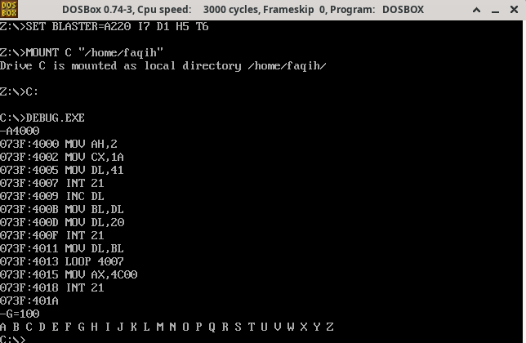
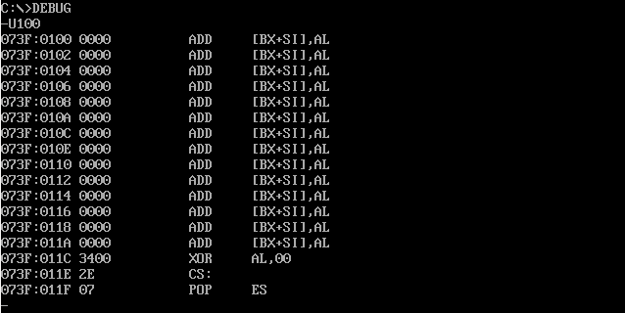

8. Output Aa1 Bb2 Cc3 Dd4 Ee5 Ff6 Gg7 Hh8 Ii9
-A4000
MOV AH,2
MOV CX,9
MOV DL,41
INT 21
MOV BL,DL
ADD BL,1

MOV BH,DL
ADD BH,20
MOV DL,BH
INT 21

MOV AL,DL
SUB AL,30
MOV DL,AL
INT 21

MOV DL,20
INT 21

MOV DL,BL
LOOP 4007

MOV AX,4C00
INT 21

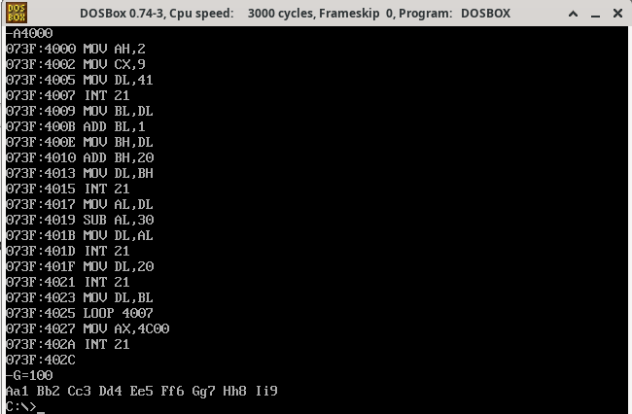
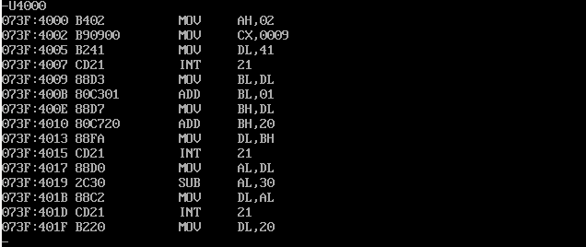
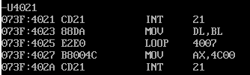

10. Output a1A b2B c3C d4D e5E f6F g7G h8H
-A4000
MOV AH,2
MOV CX,8
MOV DL,61
INT 21
MOV BL,DL
ADD BL,1

MOV BH,DL
SUB BH,30
MOV DL,BH
INT 21

MOV AL,DL
ADD AL,10
MOV DL,AL
INT 21

MOV DL,20
INT 21

MOV DL,BL
LOOP 4007

MOV AX,4C00
INT 21

